One-Health Surveillance Systems: A time series analysis of human and animal brucellosis incidence in Kenya

Samuel Kahariri1,2,3,4*, Thomas, Lian F.2,5, Bernard Bett2, Marianne Mureithi4, Anita Makori3,6, Kadivane Samuel7, Dennis N. Makau8, Nyamai Mutono3,6, Brian Njuguna3, SM Thumbi3,6,9

1Directorate of Veterinary Services, Nairobi, Kenya

2International Livestock Research Institute, Old Naivasha Road, PO BOX 30709, 00100-Nairobi, Kenya

3Centre for Epidemiological Modelling and Analysis, University of Nairobi, P.O Box 19676-00202, Nairobi, Kenya

4 Department of Medical Microbiology & Immunology, Faculty of Health Sciences, University of Nairobi

5Institute of Infection Veterinary & Ecological Sciences, University of Liverpool, Leahurst Campus, Neston, CH64 7TE, UK

6Paul G. Allen School for Global Animal Health, Washington State University, Pullman, WA, USA

7 Ministry of Health, Kenya.

8 Department of Veterinary Population Medicine, College of Veterinary Medicine, University of Minnesota, Minneapolis, USA

9 Institute of Immunology and Infection Research, University of Edinburgh

*Corresponding Author:

Samuel Kahariri -drkahariri@gmail.com

ORCID 0000-0002-3190-8543

Author Contributions

SK, LFT, BB, MM & SMT conceptualized the work. SK, AM, MN carried out the analysis. SK developed the first draft manuscript. All authors wrote the manuscript, read and approved the final draft of the manuscript.

Abstract

Brucellosis, an endemic bacterial zoonotic disease poses a significant public health challenge globally. In Kenya, brucellosis is listed among the top priority zoonotic diseases as a cause of significant morbidity in humans and production loss in livestock. Here we use national human and livestock brucellosis surveillance data to determine the temporal-spatial patterns of human and animal brucellosis in Kenya, and use the data to forecast the human cases. We obtained data on human brucellosis cases from the national surveillance system (reports from health facilities to the Kenya Health Information System) and animal brucellosis syndromic data from the Kenya Animal Biosurveillance System and data on laboratory confirmed cases from the central and regional veterinary investigative laboratories. We fitted Autoregressive Integrated Moving Average (ARIMA) and Exponential Smoothing model (ETS) time series models to the human and animal data?. In multivariable analysis, livelihood zones and animal cases at lag zero and at the third moving average (k=3), were significantly associated (P-Value ≤ 0.05) with human brucellosis occurrence. The data confirms that there exists a positive association between human and animal brucellosis. Our model indicated that all selected animal species had similar prediction capacity for human brucellosis. In conclusion, since animal species can be used as sentinels for zoonotic diseases like brucellosis, animal health surveillance data can be used to inform the human health surveillance system and therefore aid in forecasting public health events enabling timely and effective interventions. However, the surveillance systems must be sensitive enough to capture all events while ensuring they do not forecast inaccurately and give a false alarm. The existing data in the official surveillance system may not entirely reflect the situation on the ground since for instance some animal species are expected to be better predictors of human brucellosis than others. We recommend a comprehensive evaluation of both surveillance systems to identify potential gaps and better understand the observed deviation from the expected epidemiology of human brucellosis in Kenya.

Keywords: Brucellosis, surveillance, zoonotic, time series, and forecast.

Introduction

Brucellosis is a widespread and neglected zoonotic disease caused by bacteria of genus Brucella (1,2). It leads to acute febrile illness and a debilitating chronic infection in humans. In animals the infection has significant socioeconomic impact. Cattle and small ruminants, shed the pathogen in milk and in reproductive discharges and this constitutes the major sources of infection for humans and other animals. Contact with contaminated animals and consumption of unpasteurized dairy products are the main routes for human infection (3–5). Brucellosis is often underdiagnosed, misdiagnosed, or mismanaged because of its non-specific clinical presentation, low suspicion index, and diagnostic uncertainty (6,7).

Brucellosis is one of the world's most important causes of sickness in humans and animals (8). The disease is also ranked as a key priority in One Health Zoonotic Disease prioritization exercises undertaken in a number of African countries including Kenya owing to its economic and public health impacts (9–11). Globally, an estimated 500,000 new cases of human brucellosis occur annually, with the highest burden in the Mediterranean, Middle East, Asian and African regions(12). In Africa, the incidence of brucellosis varies with approximately 35-70 cases per 100,000 person-years reported in both northern and western parts of Africa . In Kenya, studies have estimated human brucellosis at about 84 per 100,000 persons (13) or a seroprevalence of between 0.1 and 46.5% (14,15). In Kenya, the Brucellosis National Prevention and Control Strategy, emphasizes the need to strengthen integrated surveillance for brucellosis towards possible elimination by the year 2040 (16).

Zoonotic infections account for nearly two-thirds of all human pathogens, 75% of the emerging infections and contribute to 43% of overall global burden of diseases (1,2). The intricate relationship between humans and animals increases the risk of emerging infectious diseases in humans and therefore, there is an international consensus to develop integrated policies to efficiently manage health issues at the human-animal-environment interface (17,18). This would facilitate a shift from isolated, sectoral, and linear, to systemic and transdisciplinary approaches to health events (19). Scientific analysis and prediction of incidence of human brucellosis cases in huimans can assist in decision making and provide recommendations for prevention measures, evaluating and formulating health financing policies (20). Previous studies have established a link between human and animal brucellosis (5,21,22). These studies used data actively collected at household level. To the best of our knowledge, no study have been undertaken to test the utility of the official surveillance data to test the association of human and animal brucellosis and forecasting of human brucellosis using animal brucellosis incidence in Kenya.

In this article, we aimed to investigate the temporal spatial pattern of the reported cases of brucellosis in human and animal surveillance systems, test the association between the reported human and animal cases and conduct a prediction analysis of human brucellosis based on the livelilihood zones and the reports of animal brucellosis. The work enabled us to understand burden of brucellosis in animal and human and investigate their relationship while exploring ways of utilizing these relationship to improve the early warning system for zoonoses.

Methodology

**Data sources.** In this study we obtained, data on the human cases of brucellosis from the Kenya Health Information System (KHIS) as monthly aggregates (23) and data on the animal (cattle, sheep, goats, and camels) cases of brucellosis at herd level from the Kenya Animal Biosurveillance System (KABS) (24) and other archived data from manual system and other pilot systems. We used the 2019 Census data obtained from Kenya National Bureau of Statistics (KNBS) to estimate human and animal populations (25). The population estimates for each year were obtained by calculating using annual population growth rate then grouped at the county level per month before merging with human and animal brucellosis data. The data covered all 47 counties of Kenya from January 2014 to December 2021.

**TSLM Model**: The time series linear model (TSLM) is a linear model that fits time series data, including trend and seasonality components. Unlike the linear model (lm), it allows controlling for trend and seasonality. TSLM is particularly useful for modeling time series data with autocorrelation, as it can handle predictor variables automatically, including trend and season.

**Data analysis:** The data data was collated, cleaned, and brucellosis incidences in human and animal species computed. The data was aggregated at monthly and county level for both human and animals. Monthly brucellosis incidence in humans was computed by employing annual population estimates and expressing rates per 1000 population. Concurrently, the 2019 animal census data was leveraged to establish species-specific populations, with brucellosis incidence rates calculated per 1,000,000 population for each species, providing a standardized metric for comparison.

To visualize and compare the trends of brucellosis incidences in different animal species and human, we plotted trends for human brucellosis incidence and a combined one for each individual animal species brucellosis incidences. To determine the spatial distribution of recorded cases of brucellosis in human and animal surveillance systems, the data was imported into QGIS and linked to county shapefiles. Choropleth maps were plotted to represent brucellosis incidence rates, employing different color gradients per percentile in all the animal species and human for quick interpretation. The resulting maps offer concise, county-level insights into brucellosis distribution, aiding targeted interventions and policy decisions.

**Measure of associations:** To test the association between our variables of interest, we fitted Time Series Linear Models (TSLM) at different lags; from 0 months to 3 months lag. The tslm model, incorporating human brucellosis incidence as the response variable and animal brucellosis incidence as a predictor was fitted using the fable package and statistical significance assessed. This test of association was conducted in three stages; individual animal species at national level, combined animal species at national level, combined animal species at individual county level and a fixed effect model for combined animal brucellosis incidence. We used AIC to select the lag where the model best fits our data. To account for effects of correllations within the counties, we also fitted a mixed effect model whose parameters were estimated using lme4 package in R.

**Forecasting Models:** We used the statistically significant variables which included; the combined animal brucellosis incidence at lag 3 and the human brucellosis incidence for human brucellosis incidence. We started by forecasting human brucellosis incidence alone then used the combined animal brucellosis incidence as an exogeneous variable in the second model.

The modeling was done by making a comparison between ARIMA and exponential smoothing (ETS) models using forecast package (26). Before fitting the model we tested for stationarity of the time series using Augmented Dickey-Fuller (ADF) test which produced a p-value of 0.8273 and therefore we failed to reject the null hypothesis that the time series has a unit root and is non-stationary. Thus necessitating differencing.

We divided the data into two part; from 2014 to 2021 as the training data set and 2022 as the test

In both models, human brucellosis incidence was used as the response variable and animal brucellosis incidences as the independent variable. We used an additive trend in the ETS model. We then undertook evaluation of the accuracy for the models using Akaike Information Criterion (AIC) and the model with the lowest AIC was selected. The selected model was used to forecast human brucellosis incidence in a 6 month time horizon. The MASE was the primary model selection criterion for this study, as it is deemed appropriate to compare the forecast models of different datasets and is less affected by the scale of data(27).

The Figure 1 below shows a methodological summary of this study.

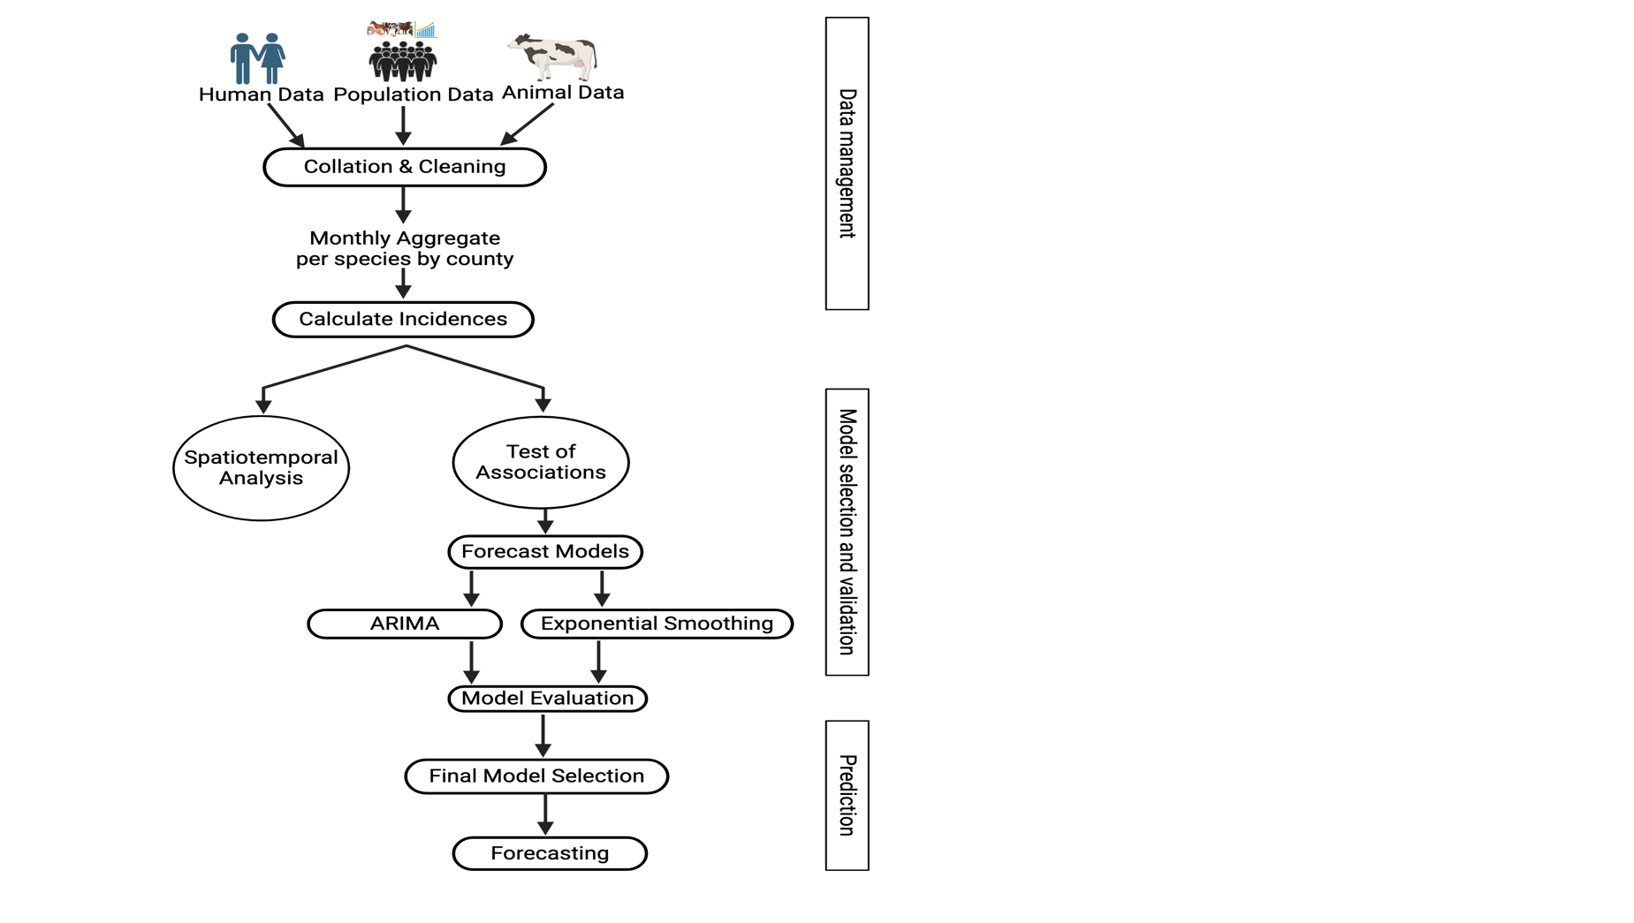

*Figure 1: summary of methodology and approach used to undertake the spatiotemporal analysis and forecast for human brucellosis incidence 2014-2021.*

**Statistical software**.

All the analysis was done using R statistical tool (R Core Team 2017).

Results

**Descriptive Analysis**

The overall number of cases observed in the study period (8 years) was 4,149,608. Humans had the highest number of cases 4,148,208 (99.96%), goat cases were 925(0.02%), cattle cases were 405 (0.01%), sheep cases were 54 ( < 0.01%), and camel cases were 16 ( < 0.01%).

Nakuru County reported the highest number of brucellosis cases in humans, totaling 309,011. Kisii County followed closely with 267,337 cases. In contrast, Lamu County had the lowest number of cases at 885. Turkana County reported the highest number of brucellosis cases in cattle at 114, followed closely by Narok County with 70 cases and Murang’a County with 26 cases. Sixteen counties had no cases of brucellosis in cattle, while 31 counties had more than one case of brucellosis in cattle.

In goats, Kwale County led with 528 brucellosis cases, followed by Turkana County with 168 cases. Thirty one counties had no cases reports of brucellosis in goats, while 16 counties had more than one reporteed cases of brucellosis in goats. For sheep, Marsabit county recorded the highest number of cases at 28, followed by Turkana with 17 and Makueni with 12 reported cases. Some counties, including Taita Taveta, Siaya, and Nyeri, had no reported cases in sheep.

Overall, 78% (xxxx/xxxx) of the reported human cases of brucellosis underwent laboratory diagnosis while in animals only 25.18% (380/1509) were laboratory diagnosed. Across the species, most cases were clinically confirmed, except for humans where most cases were lab confirmed as shown in table 2 below.

| Species | Diagnosis | Cases | Percent(%) |
| --- | --- | --- | --- |
| Camels | Clinically confirmed | 21 | 91.3 |
| Lab confirmed | 2 | 8.7 |
| Post Mortem | 0 | 0 |
| Cattle | Clinically confirmed | 228 | 55.34 |
| Lab confirmed | 170 | 41.26 |
| Post Mortem | 14 | 3.4 |
| Goats | Clinically confirmed | 815 | 82.16 |
| Lab confirmed | 177 | 17.84 |
| Post Mortem | 0 | 0 |
| Humans | Clinically confirmed | 945046 | 22.78 |
| Lab confirmed | 3203162 | 77.22 |
| Post Mortem | 0 | 0 |
| Sheep | Clinically confirmed | 65 | 79.27 |
| Lab confirmed | 17 | 20.73 |
| Post Mortem | 0 | 0 |

## Incidence Rate

The incidence rates were calculated per 1,000,000 population for all species except humans, where the incidence rate was calculated per 1,000. The mean incidence rate in humans stood at 8.191 per 1,000, while for goats, it was 0.127 per 1,000,000 goats, for cattle, 0.114 per 1,000,000 cattle, for sheep, 0.032 per 1,000,000 sheep, and for camels, 0.011 per 1,000,000 camels (refer to Table 3).

The maximum incidence rate in humans was 84 per 1,000, observed in Elgeyo Marakwet county. In goats, the maximum incidence rate was 4.83 per 1,000,000, reported in Kwale county. For cattle, Mombasa recorded the highest incidence rate of 1.41 per 1,000,000, while Tana River exhibited the maximum incidence rate for camels at 0.73 per 1,000,000. Lastly, the maximum incidence rate for sheep was 0.26 per 1,000,000, observed in Makueni county (table 4).

| Species | Mean Incidence Rate | Minimum | Median | Maximum | Standard Deviation |
| --- | --- | --- | --- | --- | --- |
| Human | 1.05 | 0.001 | 0.66 | 12 | 1.12 |
| Goat | 0.17 | 0.000 | 0 | 235 | 3.94 |
| Cattle | 0.05 | 0.000 | 0 | 122 | 2.42 |
| Camel | 0.03 | 0.000 | 0 | 24 | 0.52 |
| Sheep | 0.02 | 0.000 | 0 | 45 | 0.69 |

The average brucellosis incidence in human maintained a gradual increase from around October 2014 and peaked in July 2017. From there the average incidence experienced uneven surges and the greatest peak was experienced in August 2019 as shown in the figure below. In animals, cattle and goat incidences was seen to follow a fairly similar pattern with highest incidence being in cattle. Cases of brucellosis in camel seems to have been reported sporadically around 2015, 2019 and 2020. From the trends in the figure below, the trend in the animal brucellosis are distinctly different from the trend of the human brucellosis incidence.

## 

*Figure 2: monthly distribution of humans and animal brucellosis average incidences incidences in Kenya, 2014-2021*

Human incidence was higher than the the animal incidences with cases distributed across the all counties. The Coastal counties have consistently reported the lowest incidences of human and animal brucellosis. On the contrary, some cases were reported in 2015 in goats in Kilifi and 2018 in cattle. A big number of counties had no reported cases in animals despite having significant human incidence.

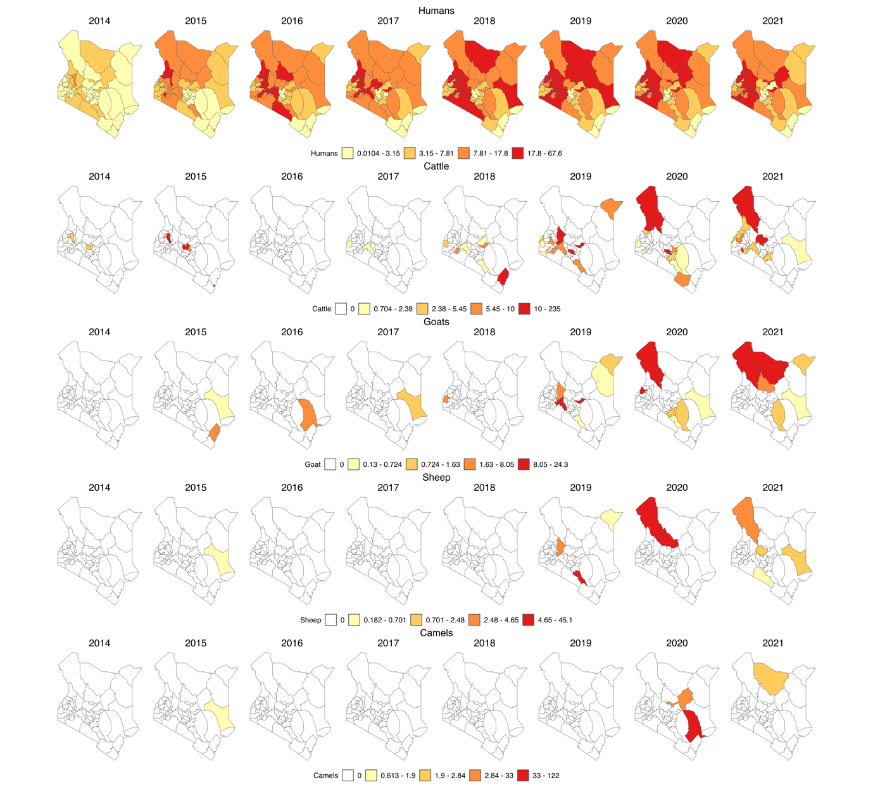

*Figure 3: yearly incidence of human and animal Brucellosis at the county level in Kenya, 2014–2021. (For humans the incidence rate is per 1,000 population while for animal species it is per 1,000,000 population, and the colour is per the percentiles).*

**Test of association**

The test of association was conducted in 3 stages; individual animal species at national level, combined animal species at national level, combined animal species at individual county level and a fixed effect model for combined animal brucellosis incidence.

**Individual animal species at national level**: The association between the human brucellosis incidence and the cattle, goat, sheep and camel brucellosis incidences was tested at 0 month lag, 1 month lag, 2 months lag, and 3 months lag. Based on the AICs for the models for the different lags, the 3 month lag had the lowest AIC and was therefore selected as the best fit for our data on individual animal species incidence.

| Lag | AIC |
| --- | --- |
| 0 | -93.43 |
| 1 | -102.23 |
| 2 | -115.97 |
| 3 | -122.87 |

Three of the four animal species brucellosis incidence showed no statistically significant association with human brucellosis incidence (p-values; camel=0.595, sheep = 0.231, cattle = 0.100, goat = 0.535) and their wide confidence intervals indicated uncertainity about the true effect they have on human brucellosis incidence.

However, at 90% confidence interval cattle brucellosis incidence was significantly associated (p-value = 0.100) with human brucellosis incidence. The true effect of cattle incidence was likely between 0.004 and 0.707.

**Combined species at national level:** The models were fitted at the three lags and evaluated using the AICs. The model with the lowest AIC was at lag 3 as shown below.

The AIC for each lag for combined species.

| Lag | AIC |
| --- | --- |
| 0 | -208.63 |
| 1 | -206.83 |
| 2 | -209.88 |
| 3 | -213.06 |

According to the model, the combined animal brucellosis incidence is a statistically significant (p-value = 0.008) predictor of human brucellosis incidence at 95% confidence interval. As suggested by the AIC, the model, is a good fit. The summary of the model output is shown in the table below.

*Time Series Linear Model results at lag 3*

| Variable | Estimate | Std.error | Statistic | P.value | Conf_low | Conf_high |
| --- | --- | --- | --- | --- | --- | --- |
| (intercept) | 0.900 | 0.036 | 24.711 | 0.000 | 0.840 | 0.960 |
| Animal incidence | 1.115 | 0.408 | 2.732 | 0.008 | 0.444 | 1.787 |

**Individual county**: We proceeded further, to test the association between combined animal brucellosis incidence and human brucellosis incidence at 3 months lag for each individual county and they were all not significantly associated (p-value > 0.05).

**Fixed effect model**: Finally mixed-effects modeling approach was employed to investigate the association between human brucellosis incidence and animal brucellosis incidence, while accounting for the hierarchical structure of the data with counties as random effects. After running the models, the results indicated that there was no statistically significant association (p-value >0.05) between human brucellosis incidence and the combined animal brucellosis incidence from the lag of zero month all the way to a lag of three months.

**Forecast**: According to the AICs for the fitted Auto ARIMA and ETS models (ARIMA AIC=XXX, ETS AIC =XXX), the Arima model had a lower AIC meaning it is a better fit for our data and therefore it was selected to forecast human brucellosis incidence. The figure XX below show the forecasted incidences.

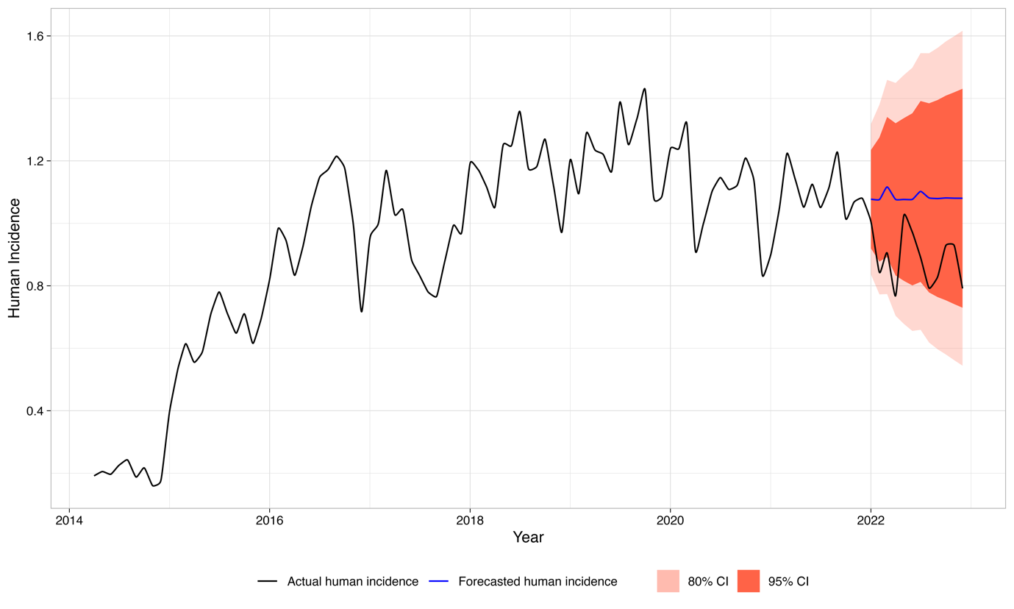

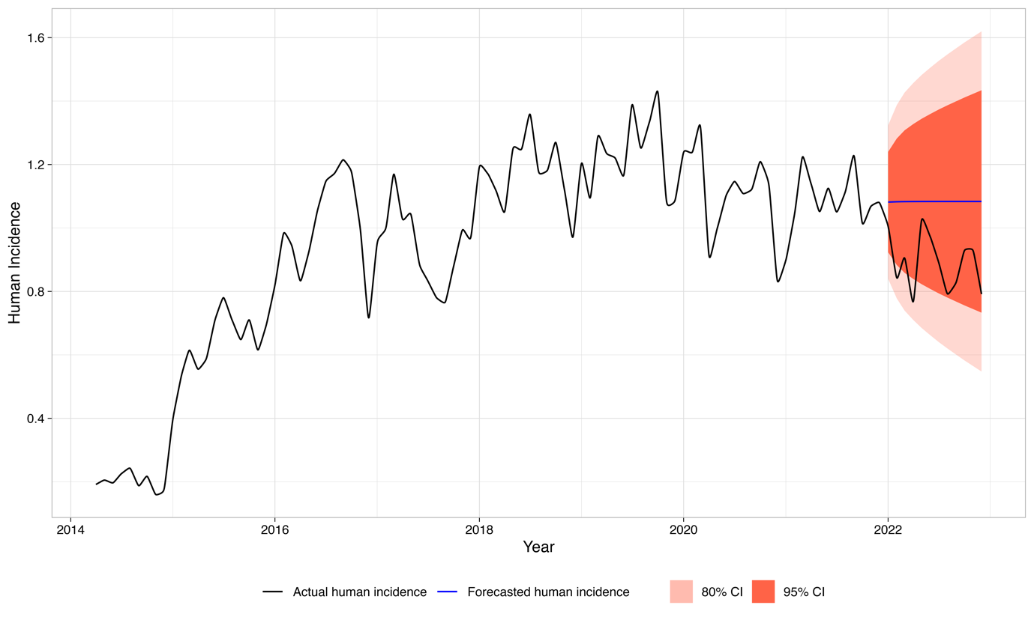

Discussion

From this study, we observe major structural differences in the human and animal surveillance systems, some of which contribute to the observed underreporting of health events. We also observe that although the occurrence of brucellosis in animals could be an indicator of brucellosis incidence in humans, none of the currently available data on different species indicate that a particular species can be a better sentinel than the rest.

In Kenya, as may be the case in many countries with similar human health infrastructure, the human health surveillance system utilizes laboratory diagnosis much more compared to the animal surveillance system. This could be true for most of the other priority zoonotic diseases in Kenya. This is most likely due to the structural differences between the two surveillance systems. In the human health surveillance system, the health facilities have varying capacities for brucellosis diagnosis ranging from basic to complex tests. Animal health surveillance mainly relies on the sparsely distributed Regional Veterinary Investigative Laboratories (RVILs) for laboratory confirmation of cases. To submit samples, veterinary practitioners could in some cases incur some expenses and this discourages sample collection. This could explain why most of the reports from the animal health sector are based on clinical diagnosis. The clinical picture of brucellosis can be confusing because unusual cases with uncharacteristic lesions continue to be reported. For this reason, diagnosis ought to be supported by laboratory tests (28). The quality of the data in animal health surveillance system is therefore, greatly affected by the conspicuously high level of underreporting and minimal utilization of the laboratory diagnostic srvices as evidenced by the study. This could compromise the utility of animal incidences of brucellosis to predict human brucellosis.

Brucellosis diagnosis has been identified as one of the major hindrances to the eradication of the disease (29) since it can be clinically confused with various other conditions in both humans and animals. Therefore, laboratory diagnosis assists in ruling out a number of these differential diagnoses. In our surveillance systems, there was a significant number of reports that were diagnosed clinically, especially in animal health surveillance. Likewise, the tests mainly used for diagnosis of brucellosis in health facilities could be highly sensitive with the possibility of having false positives. However, the study underscores the importance of utilizing laboratory diagnosis since the use of laboratory-confirmed cases of animal brucellosis improved the association of animal cases with human cases of brucellosis.

Postmortem diagnosis may not be very key in the diagnosis of brucellosis although coupled with the culture it has been seen to be important when pursuing a definitive diagnosis of brucellosis (29). From this study, the analysis reveals that the official human health surveillance system lacks mechanisms for capturing cases that may be picked during the pathological examination at the postmortem. This could lead to the loss of some important information and underreporting of human health events.

Generally, the spatial distribution and the numbers of cases (reports) captured in the human health surveillance system are comparatively much more than those captured in the animal health surveillance system. Additionally, the distribution of the animal cases does not necessarily follow the same pattern as the cases of human probably due to poor data quality. Cattle and goat incidences follow a fairly similar distribution patterns and like in previous studies, cattle cases were higher than the sheep and goat cases(30).

In the human health surveillance system, the reports are aggregated at the health facilities that are spread all over the country. On the contrary, in the animal health surveillance system, the reports are collected at the herd/farm level from villages, laboratories, clinics, crushes, and abattoirs. The vast distribution of health facilities in Kenya could also contribute to the observed higher spatial distribution and numbers of reports observed in the human population. The bulk of the cases in the animal health surveillance system were in cattle since cattle are the most widely distributed animal species in Kenya (KNBS, 2019).

Previous studies have proved existence of similar distribution pattern and trends in human and animal brucellosis (30–32). However, contrary to the findings of this study, the trend and spatial distribution of animal cases does not follow the same pattern as that in human probably due to the cases of underreporting, misdiagnosis, and other factors weakening the surveillance systems. A case in point for Isiolo county which previous studies have identified as brucellosis endemic county (32), but have not recorded any cases in animals during the study period is a good evidence of weaknesses in surveillance system that arise from inadequate reporting of health events.

focus appropriate control measures and eradication efforts on areas in which a high prevalence of animal brucellosis is present. targeted intervention policy should be implemented to break the Brucella transmission chain between animals and humans in China.

public health would benefit from a strengthening of cooperation between human and veterinary health services. (F. de Massis)

Additionally, the best model forecasts a slight increase in the incidence of human brucellosis predicated on all livestock species included in this study for the next 6 months.

Previous studies established that in developing countries, *B. abortus*, *B. melitensis,* and *B. suis* are leading causes of animal and human brucellosis (22,28) and that there is a high correlation between human brucellosis and brucella seroprevalence in animals (13,33,34). However, this study shows that all the individual animal brucellosis incidences were not significantly associated with the human brucellosis incidence. However, the combined animal brucellosis incidence was significantly associated with human brucellosis. This discrepancies could be explained by inadequacy and weaknesses in the Kenyan surveillance system and data. A slight difference would however be expected due to differences in methodology used in the studies sampling of humans and animals at the household level while our study focused on routine surveillance data. Poor quality data could arise from challenges affecting the surveillance systems. Some of the key challenges affecting the surveillance systems identified in the previous studies include; vastness and remoteness of some areas characterized by poor infrastructure and communications, the need to conduct adequate surveillance with limited financial resources (35), inadequate numbers of trained personnel (36), lack of supplies, materials, transport facilities, diagnostic facilities (37), (38), (39) “Commercial interest” (40), unharmonized reporting structures, inadequate response to disease outbreaks, lack of incentives and motivation for surveillance and political interference (39) among others.

This study had several limitations. Firstly, the use of data that included clinically diagnosed cases of brucellosis could include cases that are not brucellosis. Secondly, the use of retrospective data extracted from routine surveillance systems could be affected by reporting bias. However, for the purpose of this work, since the focus here was the surveillance system and identifying the shortfalls, the information in the official surveillance systems was extracted, collated, cleaned, and analyzed in its original state.

Conclusion

In conclusion, animal health surveillance data is important in informing the human health surveillance system and therefore be useful in forecasting public health events. However, the surveillance systems must be sensitive enough to capture all events while also ensuring they do not forecast and give a false alarm. From the study findings, we can conclude that the existing data in the official surveillance systems may not reflect the true burden of events since some findings are inconsistent with previously documented findings. The surveillance systems may therefore be inadequate to implement the disease control strategies for control of the priority zoonotic diseases in Kenya. We, therefore, recommend a deeper evaluation of the surveillance system to identify the country-specific gaps in the surveillance system to compliments the already documented challenges and come up with innovative pragmatic interventions.

The distribution of brucellosis cases in the country as manifested by the official reports may follow a similar pattern to the reporting rates by various counties and thus the need to ensure that both surveillance systems have a clearly established zero reporting for all the priority zoonotic diseases to distinguish possible absence of disease from lack or inadequate reporting.

In order to control the priority zoonotic diseases we agree with previous studies that identified the need to address the disease in the animal reservoirs and strengthen its surveillance and management in animals to reduce the incidence in human populations through a One Health framework Hull and Schumaker, 2018).

There is a need to establish and strengthen an integrated surveillance system in Kenya. This may be established outside any legal framework, and its success relies on the identification of synergies across components that could be brought together more effectively (41).

Acknowledgments

SK, BB & LFT are supported by the BMZ funded ‘One Health Centre for Research, Education & Outreach (OHRECA). LFT is also supported by the Welcome Trust-University of Liverpool Institutional Strategic Support Fund and is a Soulsby Foundation One Health Travelling Fellow. The funders had no role in the decision to publish or the preparation of this manuscript.

Conflict of interests

The authors declare no conflict of interest

References

1. Holt HR, Eltholth MM, Hegazy YM, El-Tras WF, Tayel AA, Guitian J. Brucella spp. infection in large ruminants in an endemic area of Egypt: Cross-sectional study investigating seroprevalence, risk factors and livestock owner’s knowledge, attitudes and practices (KAPs). BMC Public Health. 2011;11.

2. Who. The Control of Neglected Zoonotic Diseases A route to poverty alleviation. World Health [Internet]. 2006;(September 2005):1–65. Available from: www.who.int/zoonoses/Report_Sept06.pdf

3. Nasinyama G, Ssekawojwa E, Opuda J, Grimaud P, Etter E, Bellinguez A. Brucella sero-prevalence and modifiable risk factors among predisposed cattle keepers and consumers of un-pasteurized milk in Mbarara and Kampala districts, Uganda. Afr Health Sci. 2014;14(4):790–6.

4. Nejad RB, Krecek RC, Khalaf OH, Hailat N, Arenas-Gamboa AM. Brucellosis in the middle east: Current situation and a pathway forward. Vol. 14, PLoS Neglected Tropical Diseases. 2020.

5. Njeru J, Wareth G, Melzer F, Henning K, Pletz MW, Heller R, et al. Systematic review of brucellosis in Kenya: Disease frequency in humans and animals and risk factors for human infection. Vol. 16, BMC Public Health. BioMed Central Ltd.; 2016.

6. Franco MP, Mulder M, Gilman RH, Smits HL. Review Human brucellosis [Internet]. 2007. Available from: http://infection.thelancet.comVol

7. Bodenham RF, Lukambagire AHS, Ashford RT, Buza JJ, Cash-Goldwasser S, Crump JA, et al. Prevalence and speciation of brucellosis in febrile patients from a pastoralist community of Tanzania. Sci Rep. 2020 Dec 1;10(1).

8. Addis M. Public Health and Economic Importance of Brucellosis: A Review. Public Policy and Administration Research. 2015;

9. Munyua P, Bitek A, Osoro E, Pieracci EG, Muema J, Mwatondo A, et al. Prioritization of Zoonotic Diseases in Kenya, 2015. PLoS One [Internet]. 2016 Aug 1;11(8):e0161576. Available from: http://www.ncbi.nlm.nih.gov/pubmed/27557120

10. Sekamatte M, Krishnasamy V, Bulage L, Kihembo C, Nantima N, Monje F, et al. Multisectoral prioritization of zoonotic diseases in Uganda, 2017: A One Health perspective. Vol. 13, PLoS ONE. 2018.

11. Pieracci EG, Hall AJ, Gharpure R, Haile A, Walelign E, Deressa A, et al. Prioritizing zoonotic diseases in Ethiopia using a one health approach. One Health. 2016;2.

12. Dean AS, Crump L, Greter H, Schelling E, Zinsstag J. Global Burden of Human Brucellosis: A Systematic Review of Disease Frequency. Vol. 6, PLoS Neglected Tropical Diseases. 2012.

13. Munyua P, Osoro E, Hunsperger E, Ngere I, Muturi M, Mwatondo A, et al. High incidence of human brucellosis in a rural pastoralist community in Kenya, 2015. PLoS Negl Trop Dis. 2021 Feb 1;15(2).

14. Akoko JM, Pelle R, Lukambagire AHS, Machuka EM, Nthiwa D, Mathew C, et al. Molecular epidemiology of Brucella species in mixed livestock-human ecosystems in Kenya. Sci Rep. 2021 Dec 1;11(1).

15. Kahariri SM, Kitala PM, Muchemi GM, Njenga K, Nanyingi M. Sero-prevalence and risk factors for human brucellosis in Marsabit county, Kenya (2014). PAMJ - One Health. 2021;4.

16. Zoonotic Disease Unit K. Kenya brucellosis control strategy. Government of Kenya; 2022.

17. Jeggo M, Mackenzie JS. Defining the Future of One Health. Atlas RM, Maloy S, editors. Microbiol Spectr [Internet]. 2014 Jan 17;2(1):OH-0007-2012. Available from: https://journals.asm.org/doi/10.1128/microbiolspec.OH-0007-2012

18. The FAO-OIE-WHO Collaboration Sharing responsibilities and coordinating global activities to address health risks at the animal-human-ecosystems interfaces. 2010.

19. Queenan K, Häsler B, Rushton J. A One Health approach to antimicrobial resistance surveillance: is there a business case for it? Int J Antimicrob Agents [Internet]. 2016 Oct;48(4):422–7. Available from: https://linkinghub.elsevier.com/retrieve/pii/S0924857916301832

20. Huppert A, Katriel G. Mathematical modelling and prediction in infectious disease epidemiology. Vol. 19, Clinical Microbiology and Infection. Blackwell Publishing Ltd; 2013. p. 999–1005.

21. Muema J, Oboge H, Mutono N, Makori A, Oyugi J, Bukania Z, et al. Sero – epidemiology of brucellosis in people and their livestock: A linked human – animal cross-sectional study in a pastoralist community in Kenya. Front Vet Sci. 2022;9.

22. Osoro EM, Munyua P, Omulo S, Ogola E, Ade F, Mbatha P, et al. Strong association between human and animal brucella seropositivity in a linked study in Kenya, 2012-2013. American Journal of Tropical Medicine and Hygiene. 2015 Aug 1;93(2):224–31.

23. Cunningham Paul, Cunningham Miriam. IST-Africa 2012 conference proceedings and exhibition 9-12 May 2012, Dar es Salaam, Tanzania. IIMC; 2012.

24. Njenga K, Kemunto N, Kahariri S, Holmstrom L, Oyas H, Biggers K, et al. High Real-time Reporting of Domestic and Wild Animal Diseases Following Rollout of Mobile Phone Reporting System in Kenya. 2020;

25. KNBS 2019. 2019 Kenya Population and Housing Census. 2019.

26. Hyndman RJ, Khandakar Y. Journal of Statistical Software Automatic Time Series Forecasting: The forecast Package for R [Internet]. Vol. 27. 2008. Available from: http://www.jstatsoft.org/

27. Hyndman RJ, Koehler AB. Another look at measures of forecast accuracy. Int J Forecast. 2006 Oct 1;22(4):679–88.

28. Corbel M. Brucellosis: an Overview. Emerg Infect Dis [Internet]. 1997 Jun;3(2):213–21. Available from: http://www.cdc.gov/ncidod/eid/vol3no2/corbel.htm

29. Hull NC, Schumaker BA. Comparisons of brucellosis between human and veterinary medicine. Vol. 8, Infection Ecology and Epidemiology. Taylor and Francis Ltd.; 2018.

30. Zhou K, Wu B, Pan H, Paudyal N, Jiang J, Zhang L, et al. ONE Health Approach to Address Zoonotic Brucellosis: A Spatiotemporal Associations Study Between Animals and Humans. Front Vet Sci [Internet]. 2020 Sep 2 [cited 2024 Feb 9];7:521. Available from: /pmc/articles/PMC7492289/

31. De Massis F, Di Girolamo A, Petrini A, Pizzigallo E, Giovannini A. Correlation between animal and human brucellosis in Italy during the period 1997–2002. Clinical Microbiology and Infection. 2005 Aug 1;11(8):632–6.

32. Njeru J, Nthiwa D, Akoko J, Oyas H, Bett B. Incidence of Brucella infection in various livestock species raised under the pastoral production system in Isiolo County, Kenya. BMC Vet Res [Internet]. 2021 Dec 1 [cited 2024 Feb 9];17(1):1–12. Available from: https://bmcvetres.biomedcentral.com/articles/10.1186/s12917-021-03036-z

33. Reif JS. Animal sentinels for environmental and public health. Public Health Rep [Internet]. 2011;126 Suppl 1(SUPPL. 1):50–7. Available from: http://www.ncbi.nlm.nih.gov/pubmed/21563712

34. Pearce N, Douwes J. Research at the interface between human and veterinary health. Prev Vet Med [Internet]. 2013 Sep 1;111(3–4):187–93. Available from: http://www.ncbi.nlm.nih.gov/pubmed/23791125

35. Allport R, Mosha R, Bahari M, Swai E, Catley A. The use of community-based animal health workers to strengthen disease surveillance systems in Tanzania. 2005;24(3):921–32.

36. Halliday J, Daborn C, Auty H, Mtema Z, Lembo T, Bronsvoort BM deC., et al. Bringing together emerging and endemic zoonoses surveillance: shared challenges and a common solution. Philosophical Transactions of the Royal Society B: Biological Sciences [Internet]. 2012 Oct 19;367(1604):2872–80. Available from: https://royalsocietypublishing.org/doi/10.1098/rstb.2011.0362

37. Robertson C, Sawford K, Daniel SLA, Nelson TA, Stephen C. Mobile phone-based infectious disease surveillance system, Sri Lanka. Emerg Infect Dis [Internet]. 2010 Oct;16(10):1524–31. Available from: http://www.ncbi.nlm.nih.gov/pubmed/20875276

38. Don Bamunusinghage Nihal P, Dangolla A, Hettiarachchi R, Abeynayake P, Stephen C. CHALLENGES AND OPPORTUNITIES FOR WILDLIFE DISEASE SURVEILLANCE IN SRI LANKA. J Wildl Dis [Internet]. 2020 Jul 2;56(3):538. Available from: https://bioone.org/journals/journal-of-wildlife-diseases/volume-56/issue-3/2019-07-181/CHALLENGES-AND-OPPORTUNITIES-FOR-WILDLIFE-DISEASE-SURVEILLANCE-IN-SRI-LANKA/10.7589/2019-07-181.full

39. Omondi M, Ngere I, Ndeta C. Report on the Evaluation of Surveillance Systems Relevant to Zoonotic Diseases in Kenya-2015: A Basis for Design of an Integrated Human Livestock Surveillance System Evaluation Report [Internet]. 2016. Available from: www.zoonotic-diseases.org

40. Johnson I, Hansen A, Bi P. The challenges of implementing an integrated One Health surveillance system in Australia. Zoonoses Public Health [Internet]. 2018 Feb;65(1):e229–36. Available from: http://doi.wiley.com/10.1111/zph.12433

41. Bordier M, Delavenne C, Nguyen DTT, Goutard FL, Hendrikx P. One Health Surveillance: A Matrix to Evaluate Multisectoral Collaboration. Front Vet Sci [Internet]. 2019 Apr 24;6(April):1–12. Available from: https://www.frontiersin.org/article/10.3389/fvets.2019.00109/full